1. **INTRODUCTION**

1.1.Project overview

* Toll payment system based on block chain to provide a safer system
* This proposed model is secured and secured and least chance to temple the data
* Under GPS based tolling vehicles will need to be fitted devices that can track its movement on the highway
* Toll is merely a fee introduced to recoup the cost of road construction and maintenance
* The most implementation vehicles are equipped with an automatic radio transponder
* Road side toll reader devices can communicate with this radio transponder and register when it passes by a toll reader
* Electronic toll lanes can also operate alongside manual lanes so vehicles not equipped with the radio transponders
* Block chain smart contracts can be used to exchange anything of value without the services of middle man
* the tool readers in this case would communicate with a centralized block chain based system consisting of database registered vehicles
* toll payments itself can take place through a crypto currency e wallet
* This method is faster for drivers and makes sending and receiving transaction data easier and more secure
* Immutable and open source block chain smart contracts enable a transparent profit scheme among multiple operator
* for the automated toll collection is done manually or using tools like Radio Frequency Identification (RFID)
* we are using block chain technology for automated toll collection in the intelligent transportation system
* it is a secured and more reliable technology than the previous tools and technology
* Our work focuses on the better distribution of traffic on highway by diverting the traffic on highways with lower traffic.

1.2.PURPOSE

* The money collected through toll tax is used to sponsor the construction of roads, highways, Expressways and improve inter-state connectivity.
* The total toll tax amount that a vehicle s driver has to pay depends upon several factors such as distance of the commute, vehicle type.
* It compensates the costs of newly constructed toll roads by imposing a toll tax. It also charges for the upkeep of toll roads.
* The toll tax provides income for the NHAI, which is distributed to various private parties/contractors.

2.LITERATURE SURVEY

2.1.EXISTING PROBLEM

* The toll collection system, especially in India faces some problems such as long queue lines, escaping from toll plazas etc.
* These systems can service only 300 vehicles per hour, and if more than that number of vehicles arrives at that plaza, server traffic jams may occur.

2.2. REFERENCES

S. Nakamoto, “Bitcoin: a peer-to-peer electronic cash system,”.

https://bitcoin.org/bitcoin.pdf. Accessed by Jan. 29 2019.

[2] H. Zhou, B. Liu, T. Hao, H. Fen, L. Gui, Y. Li, Q. Yu, and X. Shen,

“ChainCluster: Engineering a cooperative content distribution framework

for highways vehicular communications,” IEEE Transactions on Intelli-

gent Transportation Systems, vol. 15, no. 6, pp. 2644-2657, Dec. 2014.

[3] S. He, D. Shin, J. Zhang, J. Chen, and Y. Sun, “Full-view area coverage

in camera sensor networks: Dimension reduction and near optimal solu-

tions,” IEEE Transactions on Vehicular Technology, vol. 65, no. 9, pp.

7448-7461, Sep. 2016

S. Nakamoto, “Bitcoin: a peer-to-peer electronic cash system,”.

https://bitcoin.org/bitcoin.pdf. Accessed by Jan. 29 2019.

[2] H. Zhou, B. Liu, T. Hao, H. Fen, L. Gui, Y. Li, Q. Yu, and X. Shen,

“ChainCluster: Engineering a cooperative content distribution framework

for highways vehicular communications,” IEEE Transactions on Intelli-

gent Transportation Systems, vol. 15, no. 6, pp. 2644-2657, Dec. 2014.

[3] S. He, D. Shin, J. Zhang, J. Chen, and Y. Sun, “Full-view area coverage

in camera sensor networks: Dimension reduction and near optimal solu-

tions,” IEEE Transactions on Vehicular Technology, vol. 65, no. 9, pp.

7448-7461, Sep. 2016

* S. Nakamoto, “Bitcoin: a peer-to-peer electronic cash system,”.https://bitcoin.org/bitcoin.pdf. Accessed by Jan. 29 2019.
* H. Zhou, B. Liu, T. Hao, H. Fen, L. Gui, Y. Li, Q. Yu, and X. Shen,“ChainCluster: Engineering a cooperative content distribution frameworkfor highways vehicular communications,” IEEE Transactions on Intelli-gent Transportation Systems, vol. 15, no. 6, pp. 2644-2657, Dec. 2014.
* S. He, D. Shin, J. Zhang, J. Chen, and Y. Sun, “Full-view area coveragein camera sensor networks: Dimension reduction and near optimal solu-tions,” IEEE Transactions on Vehicular Technology, vol. 65, no. 9, pp.7448-7461, Sep. 2016.

2.3. PROBLEM STATEMENT DEFINITION

* It does guarantee a secured transmission of the data .
* The vehicle communi-cation protocols are based on standard information technologyand cellular security mechanisms.
* These are not suitable for applications of ITS as they are not up-to-date. Collection of tolls by a toll plaza is an important aspect to be considered when we talk about any transportation system.
* For automated collection of tolls, RFID technology has been implemented in many countries.
* Using this technology, a driver has to top up the card inside a vehicle using his debit or credit card and later cards also deduct service charges of between 2-3% depending upon the issuing companies.

3.IDEATION AND PROPOSED SOLUTION

Toll Tax, often known as a toll, is a fee that vehicle drivers must pay while crossing certain interstate expressways, tunnels, bridges, and other national and state roadways. These highways are known as toll roads and are managed by the National Highway Authority of India (NHAI).

4. REQUIREMENT ANALYSIS

4.1. FUNCTIONAL REQUIREMENT

* Toll plaza electronic system shall read data from vehicle toll tags to support toll payment transactions.
* The system shall calculate the toll due based on the vehicle characteristics (vehicle size, weight, axle count, etc.), tag data, and stored toll prices.
* The system shall update the toll tag value after debiting the toll amount and send a record of the transaction to a centre.
* The system shall read the credit identity on the toll tag and send that identity and the amount to be debited to a centre.
* The system shall control roadside displays indicating success or failure of the toll transaction to the driver.

4.2.NON-FUNCTIONAL REQUIREMENTS

* Scalability: The system must be able to scale up or down as needed.
* Availability: The system must be available when needed. Maintenance: The system must be easy to maintain and update.
* Portability: The system must be able to run on different platforms with minimal changes.

5.PROJECT DESIGN

5.1.SOLUTION ARCHIETECTURE

* When the vehicle passes a roadside toll reader device, a radio signal from the reader triggers the transponder, which transmits back an identifying number which registers the vehicle's use of the road, and an electronic payment system charges the user the toll.
* A major advantage is the driver does not have to stop, reducing traffic delays.
* Electronic tolling is cheaper than a staffed toll booth, reducing transaction costs for government or private road owners.
* The ease of varying the amount of the toll makes it easy to implement road congestion pricing, including for high-occupancy lanes, toll lanes that bypass congestion, and city-wide congestion charges.
* The payment system usually requires users to sign up in advance and load money into a declining-balance account, which is debited each time they pass a toll point.

6.PROJECT PLANNING AND SCHEDULING

6.1. TECHNICAL ACHIETECTURE

* These systems utilize advanced technologies such as radio frequency identification (RFID), automatic number plate recognition (ANPR), and communication systems to automate toll payments and reduce the need for manual intervention.
* FASTag is linked to a prepaid account from which the applicable toll amount is deducted.
* The tag employs Radio-frequency Identification (RFID) technology and is affixed on the vehicle's windscreen after the tag account is active.

6.2. SPRINT PLANNING AND ESTIMATION

Sprint Goal: Define the primary objective or outcomes expected from the sprint.

• Sprint Duration: Specify the sprint duration, typically in weeks.

2. Product Backlog Review:

• Review Items: Analyze the user stories or tasks from the product backlog intended for the sprint.

• Requirements Clarification: Ensure a clear understanding of each item to be estimated and developed.

• Acceptance Criteria: Review and confirm the acceptance criteria for each item to ensure a common understanding among the team. FASTag facilitates electronic payments at the toll plaza while the vehicle is in motion. Save Time and Fuel. Customer can travel without stopping at the toll plaza by using the FASTag thus reduce congestion at plazas and , saving fuel and reduce travel time. Recharge FASTag account online.

7. CODING AND SOLUTIONING

7.1 FEATURE

FASTag facilitates electronic payments at the toll plaza while the vehicle is in motion. Save Time and Fuel. Customer can travel without stopping at the toll plaza by using the FASTag thus reduce congestion at plazas and , saving fuel and reduce travel time. Recharge FASTag account online.

8.PERFORMANCE TESTING

8.1. PERFORMANCE METRICS

There are countless payment metrics that your business could track to assess performance. Trying to measure and understand every possible data point can be unmanageable and lead to unfocused, ineffective decision-making. With that in mind, here are the five key payment metrics that should form the backbone of your strategy

9.RESULTS

It shows the Irish toll data statistics for year 2019[41]. It includes monthly trafﬁc and Electronic Toll Collection(ETC) tag data of M50 e-Flow toll plazas in Ireland. During January there was a total of 4.30M trips and 68.1 percent of those trips were electronic tag trips (2.93M). For the month of February, there was a total of 4.12M trips and 68.1 percent of those trips were electronic tag trips (2.81M). Finally, for the month of March, there was a total of 4.56M trips and 66.8percent of those trips were electronic tag trips (3.05M).

9.1. OUTPUT SCREENSHOTS

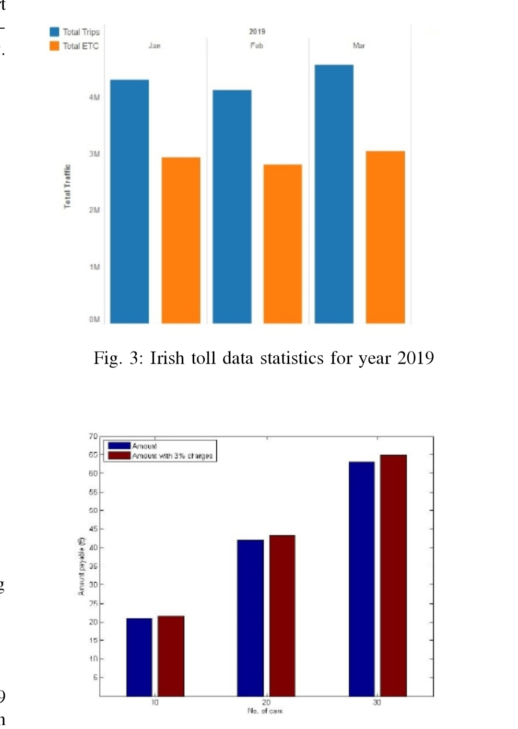

10.ADVANTAGES AND DISADVANTAGES

The major disadvantage of preferring a toll road over the free road is just the toll charges or fees paid for the service. However, the advantage is that due to the premium nature of toll roads as compared to the free road, the time consumed would be relatively low when using toll roads. The ETC helps in making the high speed tolling operations possible as the drivers don't get to stop and make the payments in between. This helps in reducing the financial vulnerability as well as the frauds because automatic payments don't need any cash handling.

11.CONCLUSION

New and ideal models are being proposed every year in the ﬁeld of vehicular communication for intelligent transportation system. In the paper, a solution for the toll fee collection is presented and better distribution of trafﬁc on highways in the intelligent transportation system. Previously, toll is being collected either by humans or using RFID which is automated .As thousands of vehicles pass from the tolls on highways on a daily basis, a secure and reliable mechanism is required to manage the toll collection. We present a block chain technology which is permission less and keep track of all the vehicular transactions which are passing from the toll. Smart contracts are used for implementing the fee-paying mechanism and it is more reliable than the cash cards because these can be lost at any time. An incentive-based mechanism can be introduced in addition to the smart contracts in future studies for more reliable and controlled management of vehicles on the highways.

New and ideal models are being proposed every year in the

ﬁeld of vehicular communication for intelligent transportation

system. In the paper, a solution for the toll fee collection

is presented and better distribution of trafﬁc on highways in

the intelligent transportation system. Previously, toll is being

collected either by humans or using RFID which is automated.

As thousands of vehicles pass from the tolls on highways on

a daily basis, a secure and reliable mechanism is required to

manage the toll collection. We present a blockchain technology

which is permission less and keep track of all the vehicular

transactions which are passing from the toll. Smart contracts

are used for implementing the fee-paying mechanism and

it is more reliable than the cash cards because these can

be lost at any time. An incentive-based mechanism can

New and ideal models are being proposed every year in the

ﬁeld of vehicular communication for intelligent transportation

system. In the paper, a solution for the toll fee collection

is presented and better distribution of trafﬁc on highways in

the intelligent transportation system. Previously, toll is being

collected either by humans or using RFID which is automated.

As thousands of vehicles pass from the tolls on highways on

a daily basis, a secure and reliable mechanism is required to

manage the toll collection. We present a blockchain technology

which is permission less and keep track of all the vehicular

transactions which are passing from the toll. Smart contracts

are used for implementing the fee-paying mechanism and

it is more reliable than the cash cards because these can

be lost at any time. An incentive-based mechanism can

New and ideal models are being proposed every year in the

ﬁeld of vehicular communication for intelligent transportation

system. In the paper, a solution for the toll fee collection

is presented and better distribution of trafﬁc on highways in

the intelligent transportation system. Previously, toll is being

collected either by humans or using RFID which is automated.

As thousands of vehicles pass from the tolls on highways on

a daily basis, a secure and reliable mechanism is required to

manage the toll collection. We present a blockchain technology

which is permission less and keep track of all the vehicular

transactions which are passing from the toll. Smart contracts

are used for implementing the fee-paying mechanism and

it is more reliable than the cash cards because these can

be lost at any time. An incentive-based mechanism can

New and ideal models are being proposed every year in the

ﬁeld of vehicular communication for intelligent transportation

system. In the paper, a solution for the toll fee collection

is presented and better distribution of trafﬁc on highways in

the intelligent transportation system. Previously, toll is being

collected either by humans or using RFID which is automated.

As thousands of vehicles pass from the tolls on highways on

a daily basis, a secure and reliable mechanism is required to

manage the toll collection. We present a blockchain technology

which is permission less and keep track of all the vehicular

transactions which are passing from the toll. Smart contracts

are used for implementing the fee-paying mechanism and

it is more reliable than the cash cards because these can

be lost at any time. An incentive-based mechanism can

New and ideal models are being proposed every year in the

ﬁeld of vehicular communication for intelligent transportation

system. In the paper, a solution for the toll fee collection

is presented and better distribution of trafﬁc on highways in

the intelligent transportation system. Previously, toll is being

collected either by humans or using RFID which is automated.

As thousands of vehicles pass from the tolls on highways on

a daily basis, a secure and reliable mechanism is required to

manage the toll collection. We present a blockchain technology

which is permission less and keep track of all the vehicular

transactions which are passing from the toll. Smart contracts

are used for implementing the fee-paying mechanism and

it is more reliable than the cash cards because these can

be lost at any time. An incentive-based mechanism can

New and ideal models are being proposed every year in the

ﬁeld of vehicular communication for intelligent transportation

system. In the paper, a solution for the toll fee collection

is presented and better distribution of trafﬁc on highways in

the intelligent transportation system. Previously, toll is being

collected either by humans or using RFID which is automated.

As thousands of vehicles pass from the tolls on highways on

a daily basis, a secure and reliable mechanism is required to

manage the toll collection. We present a blockchain technology

which is permission less and keep track of all the vehicular

transactions which are passing from the toll. Smart con

New and ideal models are being proposed every year in the

ﬁeld of vehicular communication for intelligent transportation

system. In the paper, a solution for the toll fee collection

is presented and better distribution of trafﬁc on highways in

the intelligent transportation system. Previously, toll is being

collected either by humans or using RFID which is automated.

As thousands of vehicles pass from the tolls on highways on

a daily basis, a secure and reliable mechanism is required to

manage the toll collection. We present a blockchain technology

which is permission less and keep track of all the vehicular

transactions which are passing from the toll. Smart contracts

are used for implementing the fee-paying mechanism and

it is more reliable than the cash cards because these can

be lost at any time. An incentive-based mechanism can

New and ideal models are being proposed every year in the

ﬁeld of vehicular communication for intelligent transportation

system. In the paper, a solution for the toll fee collection

is presented and better distribution of trafﬁc on highways in

the intelligent transportation system. Previously, toll is being

collected either by humans or using RFID which is automated.

As thousands of vehicles pass from the tolls on highways on

a daily basis, a secure and reliable mechanism is required to

manage the toll collection. We present a blockchain technology

which is permission less and keep track of all the vehicular

transactions which are passing from the toll. Smart contracts

are used for implementing the fee-paying mechanism and

it is more reliable than the cash cards because these can

be lost at any time. An incentive-based mechanism can

12.FUTURE SCOPE

Global Electronic Toll Collection Market Outlook for 2023 to 2033. The worldwide demand for Electronic Toll Collection Systems, in terms of value, is estimated to be around US$ 12.46 billion in 2023. The global electronic toll collection market predicts the overall demand to rise at 10.6% CAGR from 2023 to 2033.

Designed a system to give complete solution for traffic and transport related problems such as Toll gate control , traffic signal control, traffic rules violation control, parking.

13. APPENDIX

